Osgoode ITS
Osgoode Webforms User Manual

This manual has been created to help users with the Osgoode Webforms website. A webform is and online form that has submission results and statistics recorded and accessible to privileged users.

Table of Contents
Introduction 2
Logging In 3
Changing Your Account Settings 4
Creating Content 5
Form Components 5
E-mails 9
Form Settings 9
Arrange Fields 9
Results 10
Submissions 10
Analysis 10
Table 10
Download 10
Clear 10

Introduction
This guide describes how to get started using (as opposed to administrating) a Drupal-powered web-site and covers basic topics such as logging in, changing your account settings, and creating forms.
Drupal is a content management system. Its goal is to help users compose and present web-site content such as articles, photos, and other content types. For this particular website, it allows for the creation of online forms.
Most of the content on a Drupal-based site is stored in a database. Text and images are submitted by filling in forms via a web browser. When visitors view a page, Drupal gets the relevant bits of content from the database and composes all of the components of the page in a template. This makes it easy to quickly add or change content, without requiring knowledge of HTML or other web technologies on the part of the person providing the content.
Depending on the configuration of the Drupal site and the defined user-roles on the site, you may be allowed to contribute and edit content or administer various aspects of the site. Fortunately, Drupal is designed to make this relatively easy. Very little technical knowledge is assumed. Though details may vary with a site's configuration, the basic process involves these steps:
- log in by typing the user name and password supplied you in the registration step
- create content (webforms)
This user guide will explain these steps and familiarize you with the basic information you need to use Drupal successfully.

Logging In
Before you can add or edit content, you usually need to log in. If you haven't already done so, register as a user by contacting the help desk (help@osgoode.yorku.ca) and requesting a user account. Then go to the login page for the site (http://forms.osgoode.yorku.ca/user).
Enter your username and password and click “Log in”. 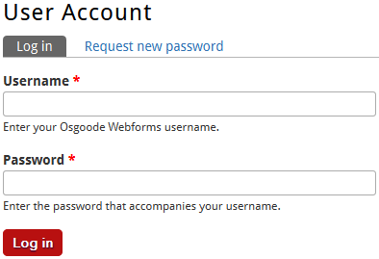
If you forget your password:
Please request a password reset from the help desk (help@osgoode.yorku.ca).

Changing Your Account Settings
Once you have logged into the site, you can change user settings such as password and email address. To see what tweaks you can make to your account, log in and then click on the “Edit” tab.
Password
Enter in a new password in both fields to set it. It is recommended that you change your password to something you can easily remember.
Email address
The site requires a valid email address. All emails for the system will be sent to this address.

Creating Content
Once you have logged-in, you're ready to start creating new webforms.
At the top menu click the link “Content”. A list of previously created webforms will appear. To create a new webform , click “Add content” and then click “Webform”. The Create Webform page will appear.
- Title: Title of the webform
- Body: Body text that comes after the title. (Useful for form instructions or description)
- Groups Audience: Share editing capability with a predefined group of users
- Webform Results Access: Share the webform results with other users
- URL path settings: Optionally specify an alternative URL by which this content can be accessed.
Click “Save” and the webform has been created. The next step is to add form components.

Form Components
- Date
This component type provides a place for users to submit a date: month, day, and year. You have control over what time zone is used and how you want users to provide a year, either a dropdown list or a text field.
- Email
This component will give users a text field to provide a valid email address, and only properly formatted addresses will be accepted. You also have the option of sending a copy of the submission email to this address
.
- Fieldset
This component allows you to group other components into boxes. You can choose to make each box collapsible. To put other components into a fieldset, when viewing the list of components, drag the component below the fieldset in the list and then to the right to indent it below the fieldset.
- File
This component allows users to upload files with their submissions. You can control what file types are allowed, how large files can be, and where they are stored. Note: A "File" component must appear after the last "Pagebreak" component.
- Grid
This component provides a common set of "Options" for a list of "Questions." Options appear across the top, questions down the left. Each spot in the grid has a radio button, and only one option may be chosen for each question. You are able to randomize the order of the options, questions, or both.
- Hidden
This component can be used to store information not shown to users submitting the form.
- Markup
This component can be used to insert HTML code into your form.
- Pagebreak
This component is used to break your form into pages. The submit button will not be visible until a user completes the final page of the form. Note: If your form has a "File" component, it must appear after the last "Pagebreak" component.
The Pagebreak also lets you set a Conditional rule, which determines how people filling out the form will get to the page. This lets you have an answer to one question on your form lead to a set of other questions. This behavior is sometimes called branching logic. To use this, the Pagebreak must come after at least one other form component. To use this:
- Expand the Conditional rules field on the Pagebreak form component configuration screen.
- Select the Component whose value will determine whether to show the page.
- Select either Is one of or Is not one of to determine whether to show the page.
- Enter the Values that will determine whether to show this page.
- Click Submit.
- Select options
This component allows users to respond to prompts. You can create single response questions (radio buttons, dropdown lists) as well as multiple response questions (checkboxes, multi-select lists).
The Select options component features a GUI interface for adding options. If you want to revert to the manual method for editing options, click the Manual entry link below the option boxes. The value of each item can be entered in the text field contained in each row. If you want to be sent a different value for an option than appears for the user (ex. "One" appears on the form and you are sent "1"), click the Customized keys (Advanced) checkbox and enter the value you wish to be sent in the text field to the left of the value displayed to the user.
The default option for this element can be set by clicking the radio button to the left of the appropriate value. Values can be rearranged by dragging the cross glyph to the left of these radio buttons. You can add a new row below any existing row by clicking the green cross glyph on the right and you can remove any row by clicking the red X glyph on the right. You can also choose to Randomize options by clicking that checkbox to display the options in a random order for each person visiting the form.
If you want to allow people submitting the form to supply their own option if an appropriate one does not appear in the list, check the Allow "Other..." option and enter the appropriate text in the Text for "Other..." option text field.
- Textarea
This component provides a box for users to type in. You can make this box resizable.
- Textfield
This component provides a single-line text field for users to type in.
- Time
This component type provides a place for users to submit a time. You can control what time zone is used, as well as whether to use 12-hour (am/pm) or 24-hour format.
- Matrix/Table
Allows a matrix of responses for any type of component.
- Name
Adds a component for collecting personal names.
Adding Form Components
After you click the Save button when creating a new Webform, you will be taken to the form components page. If you are editing an existing Webform, you can get to this page by clicking the Edit link at the bottom of the form and then clicking Form components tab in the Webform Console.
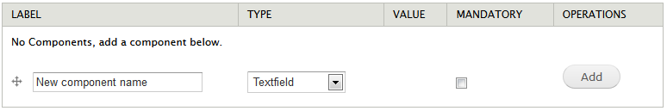
To add a component:
- Give the component a unique name. The name:
  - Appears in bold above the interactive part of the component, followed by a colon.
- Use the dropdown menu to choose the component type.
- If you want the component to be mandatory for people submitting the form, make sure the "Mandatory" checkbox is marked.
- Click the "Add" button.
  - You are now in the editing interface for the form component type you have chosen.
- When you are finished setting up the component, click the "Submit" button.
  - You are returned to the "Form components" page.
To edit an existing component, go to the "Form components" tab in the editing interface for your form and click the "Edit" link next to the component you wish to change. This will bring you to the appropriate form component editing interface.
To reorder existing components, use the icons left of the component names to drag them into the correct order, then click the "Save" button.
All component types have 3 common fields in their editing interfaces. The "Label" field inherits the name you assigned in the steps above, and is displayed above the interactive piece of your component. The "Default value" field allows you to have parts of your form already filled in. The "Description" field allows you to provide more information for users and is displayed below the interactive portion of the component.

E-mails
Currently Osgoode Webforms does not send notification emails.

Form Settings
This tab contains some of the advanced settings that were previously on the edit form.
Confirmation Message
You can, optionally, add a message to appear after a user submits the form. Leaving this blank gives a default message of completion after a user submits the form. It is highly recommended that you use this space to provide a link back to your website.
Redirection Location
A custom redirect URL will bring a user to that page after submitting the form. If you leave this blank or choose the confirmation message, the user will see that message instead. You can also choose not to redirect the user, which will reload the current form page when they submit the form.
Submission Limit
This area allows you to limit user submissions. By default, a user can submit an unlimited number of responses, but you can restrict them to a specified number of submissions over a specified amount of time.
Advanced Settings
You can ignore the Show complete form in teaser checkbox as this option is unnecessary. The option of interest here is Allow users to save a draft. This option is only useful if your form requires users to sign in before filling it out. If you use this option on a form that allows anonymous users to submit it, it may behave erratically. However, if you require people to sign in to fill out your form and this option is selected, they will be allowed to save a draft of their form submission. This will not send emails from the form, but they will be able to come back to the form at a later time and complete their form submission. This is a good option if you have a very long form, especially one that requires people to gather written materials or files before they submit it.
This section also allows you to change the text of the submit button, which is Submit by default.

Arrange Fields
This tab allows you to drag-and-drop fields into the order which you want them to appear on the webform entry page.

Results
The Results tab will allow you to access the submissions of your webform.

Submissions
The Submissions tab will show you a table listing the submissions to date. You can view, edit, or delete each submission separately.
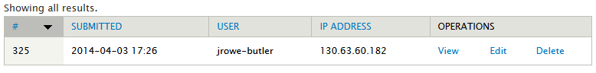

Analysis
The Analysis tab will show a table with the analyzed data for each question.
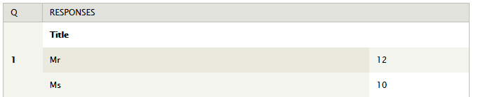

Table
The Table shows all the results in a tabular format.

Download
The Download tab has two options that can help you when exporting form information to Microsoft Excel or another analysis program. The “Select List Options” allows you to choose whether to use human-readable or shorter column headers. You can also choose to export multi-values fields as separate columns or as a compact, comma-delimited list. In the “Included Export Components” fieldset, you can decide which of the components to include, which is helpful if you are only interested in analyzing a sub-set of the form information. The “Download Range Options” allows you to choose a range of submissions to export.

Clear
The Clear tab allows you to delete all the submissions from that form. This action cannot be done and erases all of the submissions from the database.

