HOW TO Add York Atlas to IBM Notes

HOW TO Add York Atlas to Lotus Notes
The York Atlas is York University’s online email and phone directory, accessible from the York University home page, and can be added as an additional address book inside IBM Notes.

Adding York Atlas to your Lotus Notes Address Book
- Connect to the Internet and open your Lotus Notes.
- Click on the Address Book icon.
- Click Advanced and then select NewAccount.
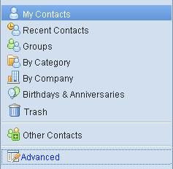

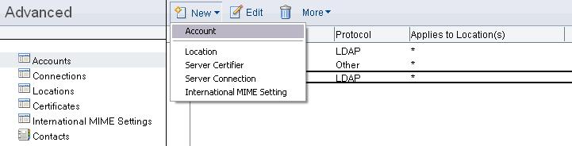

- Enter the information in the different tabs as shown below:
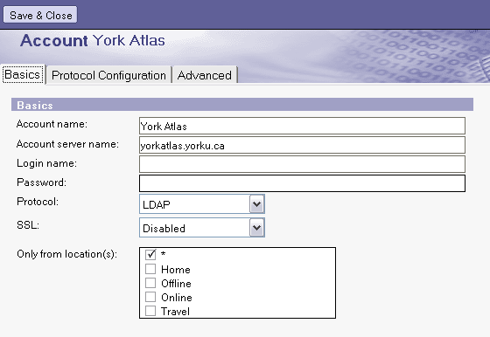
Protocol Configuration
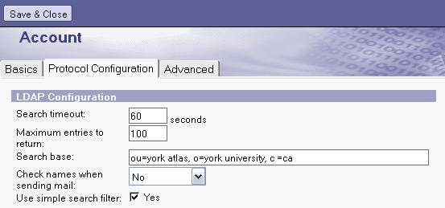
Search Base: ou=york atlas, o=york university, c =ca

Advanced Settings
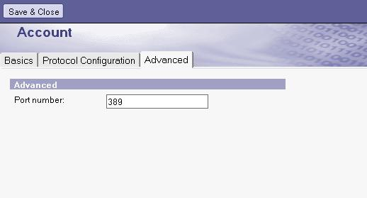

- Click on Save and Close. Close your address book. You are now ready to access York Atlas email addresses.

Send Email to a Person in the York Atlas
Please Note that Osgoode faculty, staff and students are also listed in the York Atlas. To send an email to an Osgoode person, it is preferable to use the Osgoode address books, as information might be inaccurate in the York Atlas, especially for students.
- In a New E-mail, Click “To:” to open up the Address Book.
- From the Directory, click the arrow and select York Atlas. In the For field, type the last name of the person to whom you would like to send an email. Click on the Search icon.
