HOW TO Install IBM Notes
Follow these instructions to install and configure IBM Notes 9 on your computer.
Note: These instructions are written for Microsoft Windows. If you are using a Mac, there will be some slight variations to the install process.

Requirements
You will need the following to configure Lotus Notes on your home computer:
- Installer and ID file from the Osgoode ITS Helpdesk
- The computer you are using needs to be connected to the Internet.

Client Installation
- Double-click on My Computer, then open the USB drive
- Open the IBM_Notes_9 folder, then double-click on Setup.exe
- Wait for the files to extract. When the installation window appears, click Next
- On the License Agreement screen, select I accept the terms in the license agreement. Click Next
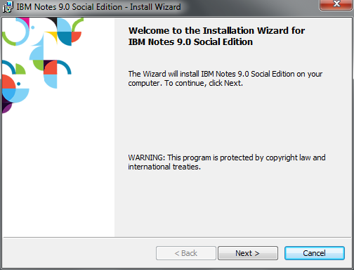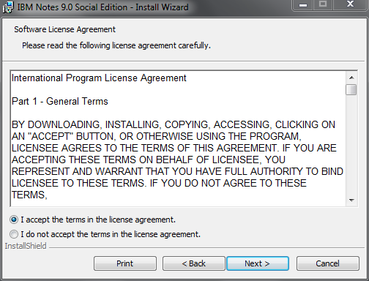

- On the Customer Information screen, select Anyone who uses this computer (Multi-User Install). Click Next.
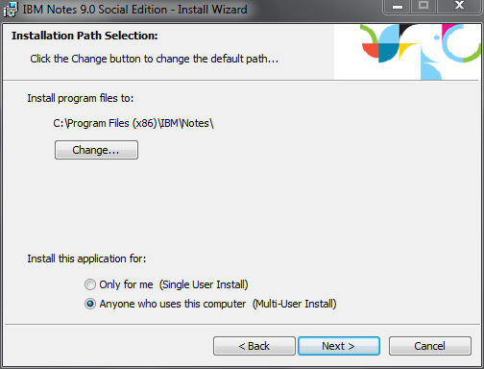

- On the Custom Setup screen, select Install or Do not Install next to the following options:
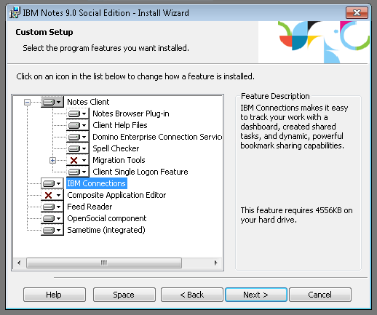

- On the Ready to Install the Program screen, check off Launch parts of Notes when the operating system starts to enable faster Notes startup then click Install
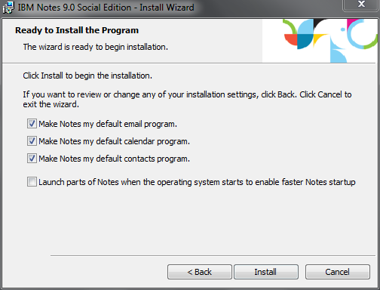

- The IBM Notes client will install on your computer, which may take several minutes. When it is done, click Finish
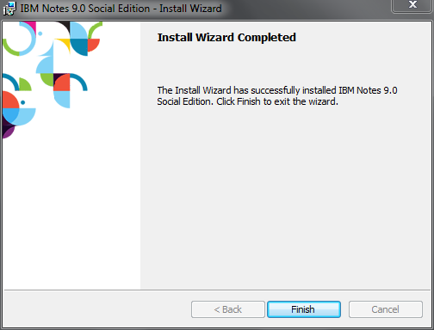

Configure IBM Notes
- Double-click the IBM Notes 9 icon on your desktop.
- On the Welcome screen, click Next
- Under Your name, enter your full name (i.e. “John Doe”). In the Domino Server field, type “inotes/osgoode”. Click Next
  - Note: If LCO, type “mail/lco-cdo” instead
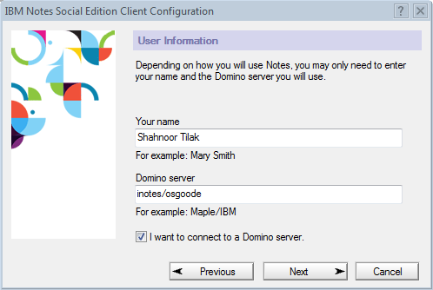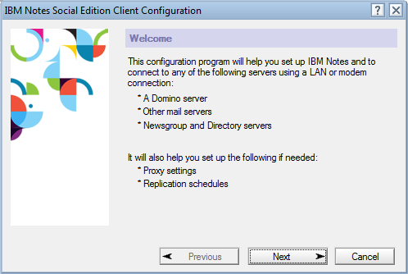

- Select Set up a connection to a local area network (LAN) and then click Next
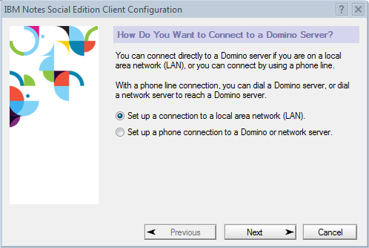

- Under Domino server name, enter inotes/Osgoode
  - If LCO, enter mail/lco-cdo
- Drop-down Select Network Type and select TCP/IP
- Under Server address, enter deed.osgoode.yorku.ca
  - Note: If LCO, enter commission.osgoode.yorku.ca instead
- Click Next
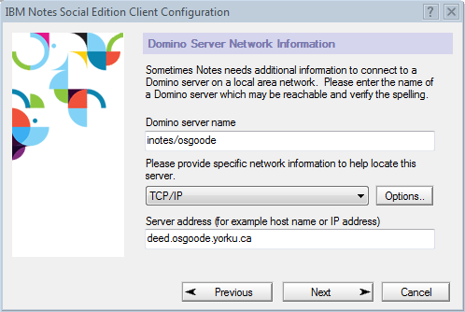
- On the Notes ID File screen, click on Browse... Select your ID file from the CD you were provided, then click Next
- Click Yes to copy your ID file to the data directory.
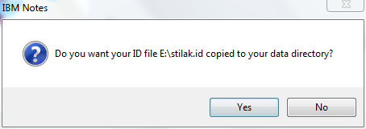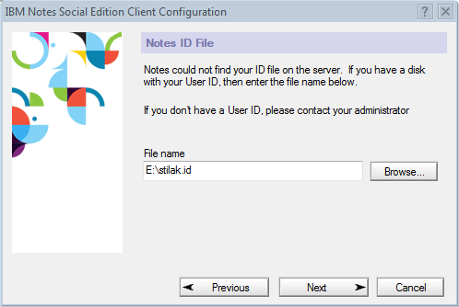
- You will be prompted for a password. Enter “changeme”
- On the next screen, click Finish
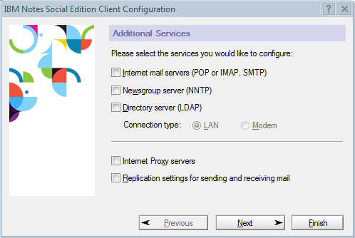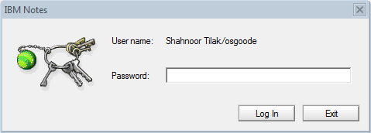

- Close the Getting Started tab.
- On the Home screen, click on Use the Default
- Click on File, Security, User Security. Enter “changeme”
- Click on Change Password ... Enter “changeme”
- Enter the password you would like to use twice, and click OK
- Click on File – Preferences – Web Browser
- Select Use the browser I have set as the default for this operating system

Mandatory Setup Contacts Replication and Lookup Preferences by following the steps below.

Setup Contacts Replication

- Click on the blue Open button, and select Replication and Sync
- Place a checkmark under Enabled, beside Synchronize Contacts
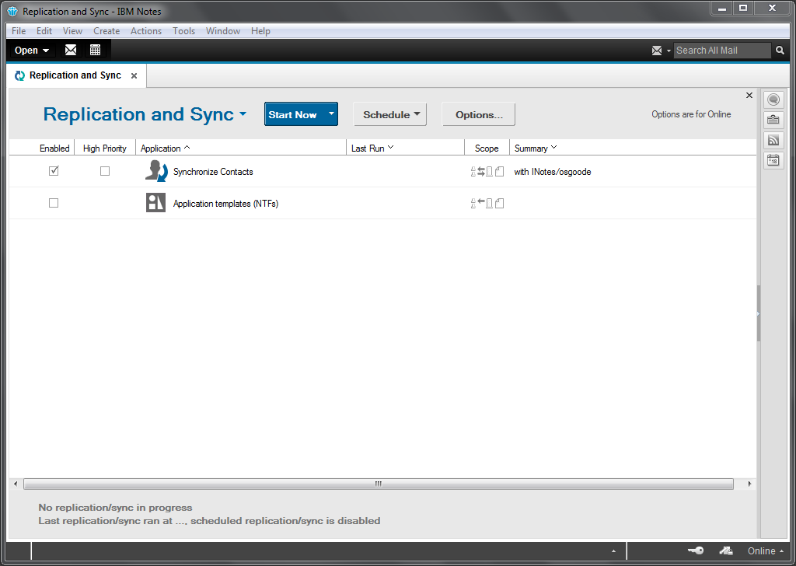
- Click Schedule then Enable Scheduled Replication/Sync
- Click Schedule again, Set Replication/Sync Schedule ...
- Towards the bottom of the window, place a checkmark beside Replicate/Sync when I start the client and Replicate/Sync when I shut down the client
- Click OK
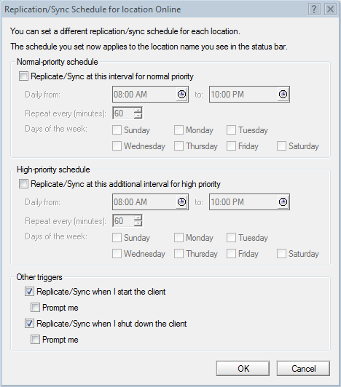

Change Lookup Preferences
- Click on File – Preferences – Locations
- Select Online and click Edit
- Click on the Mail tab
- Change the Recipient name lookup: to Exhaustively check all address books
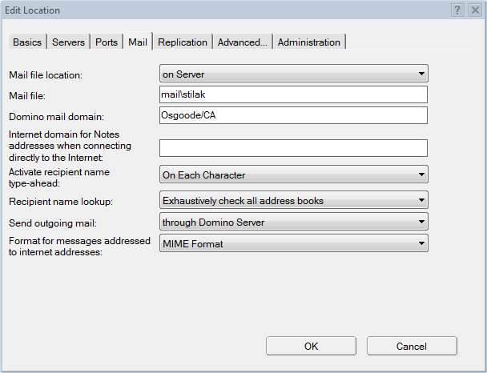

Install IBM Notes for MacBook Pro with TouchBar
- Ensure all traces of IBM Domino (current or present installation) has been removed from the computer.
- Ensure the latest version of Java Run Time is installed.
- Run the base installer M:\HELPDESK\SOFTWARE\IBM Domino\IBM Notes\IBM Notes 9.0.1\Notes_Mac_901\IBM_Notes-Mac-9.01.dmg
- Then run the patch immediately after. M:\HELPDESK\SOFTWARE\IBM Domino\IBM Notes\IBM_Notes_Hotfix_901SHF766.dmg
- Open IBM Notes and configure it for Osgoode

